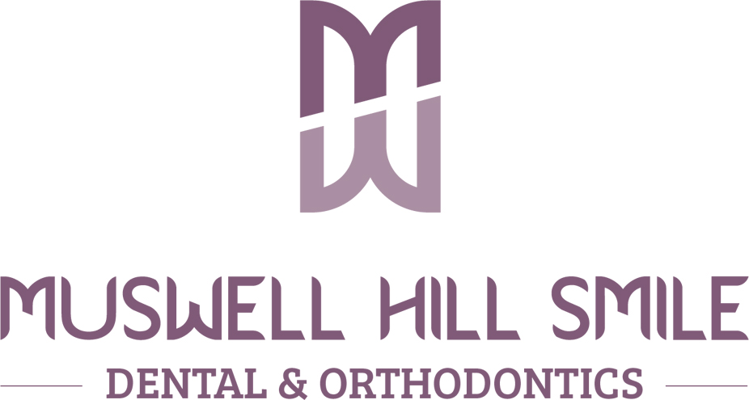

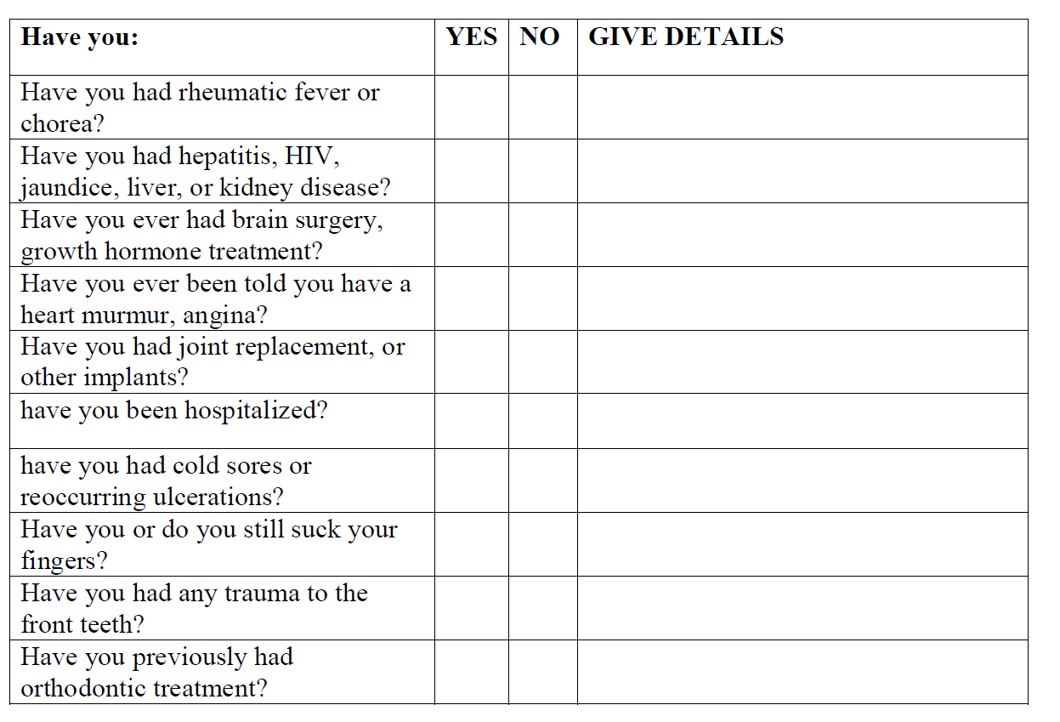

115 Alexandra Park Road, London N10 2DP | Tel: 020 3355 0552

Personal Assessment and Medical History Form
PRIVATE AND CONFIDENTIAL

Family Name ………………………………………........................ Mr Mrs Ms Miss
First Name.................................................... Date of birth ……………..................................
Address……………………………………………………………………………………………………......
City…………………………………………………………… Postcode…………………………….....
Home phone no……………………………… Mobile no…………………………….... Email address …………………………………………………...............................................................
Dentist Name(if applicable)............................................................................
How did you hear about us ............................ Occupation …………………….........

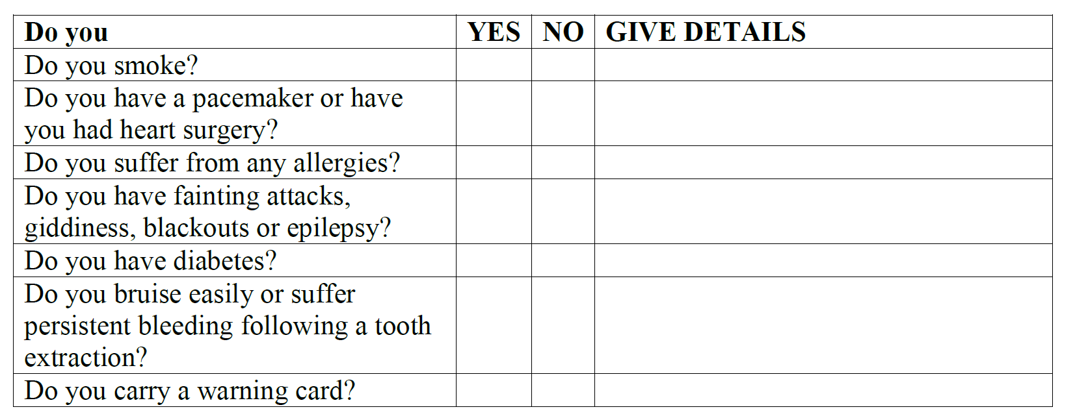

Are there any other aspects concerning your health that you think the dentist should know about? ………………………………………………………………………………………………………………………..

Alcohol units consumptions per week: None □ 1-5 □ 5-10 □ 10+□

Your Doctor’s (GP) name and address:
…………………………………………………………………………………………
I understand and agree to the following:

■ E-mail addresses will only be used for communications in connection with orthodontic or Dental treatments
■ Clinical photographs and radiographs might be taken for my treatment records.
■ I will be charged a fee of £50 for each 15 minutes of an appointment missed
or cancelled without 24 hours notice.

Signature…………………………………………………………… Date………………………………………………
Please tell the dentist if you have a disability that the practice should be aware of to ensure that our services are appropriate to your needs.

